1. **Masiva Solution, Mumbai**

**Address:** 104, Natwar house 1st floor R.N. 3, Ardeshir Dadi St, Cawasji Patel Tank, mumbai 4, Mumbai, Maharashtra 400004

**Phone number:** +91 89288 72834

**Website:** <https://www.masivasolution.com/>

Very good reviews on google for this company product.

Power bank capacity-5000 mAh with 1 year warranty.

50 pieces- Rs.300+18%GST and for logo printing Rs.10 per piece

100 pieces- Rs.280+18% GST and logo printing Rs.10 per piece

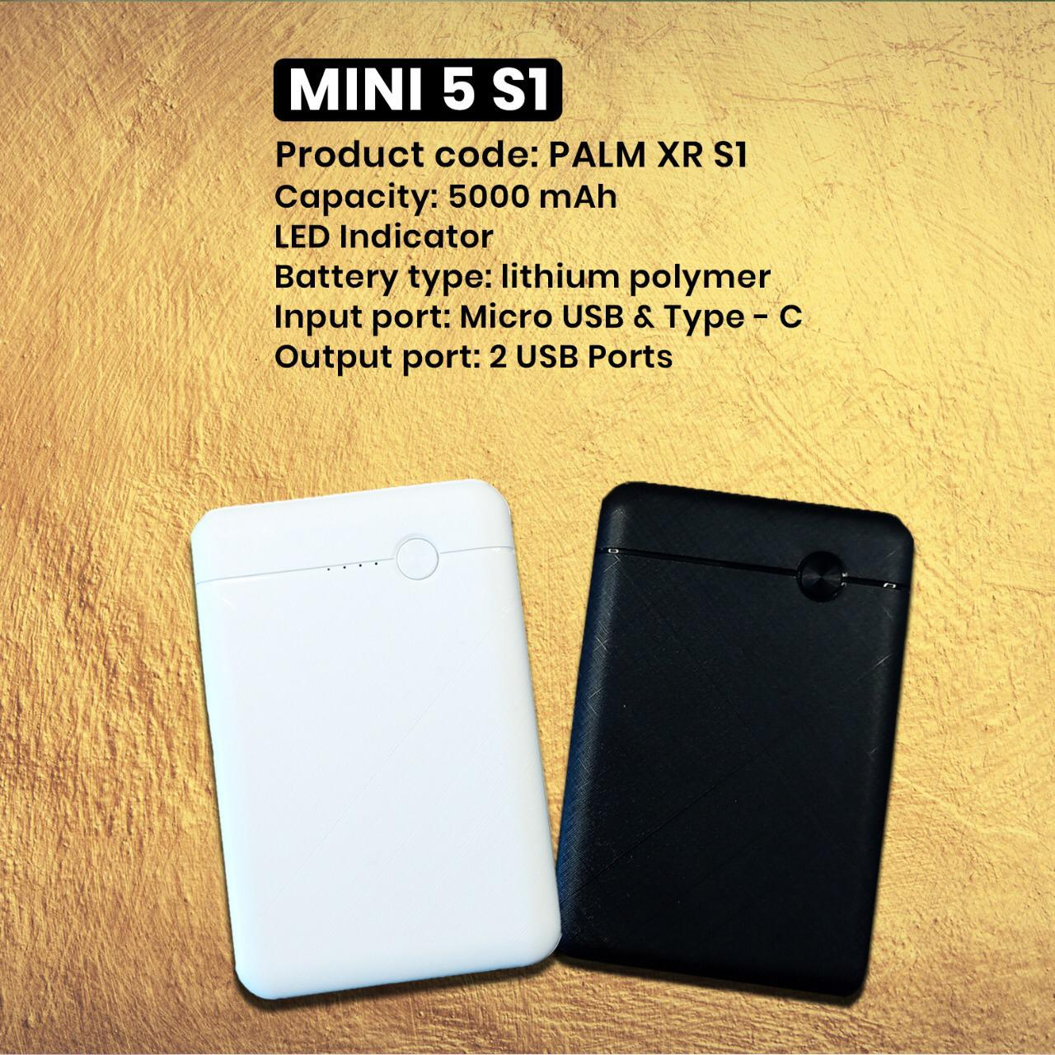

Figure 1power bank image

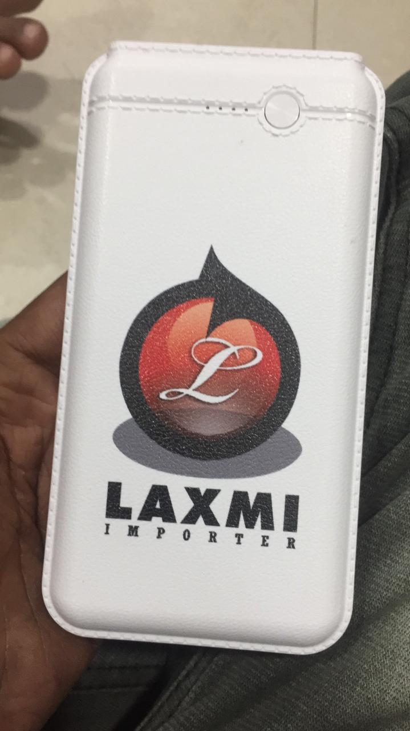

Figure 2: Image after logo printing

1. **SSM creative solutions, Mumbai**

**Address**: RM No. 551, Raju Chawl Snow Way Hot, Gazdarban, Gazdar Ban Road Nr. Poddar School, Road, Santacruz West, Mumbai, Maharashtra 400054

**Phone number:** +91 93242 43827

**Website:** <https://www.ssmcreativesolutions.com/>

Power bank capacity-5000 mAh with 1 year warranty.

50 pieces- Rs.255+18%GST and for logo printing Rs.15 per piece

100 pieces- Rs.250+18% GST and logo printing Rs.15 per piece

